BRAC University (Department of Computer Science and Engineering)

CSE 221 (Algorithms) for Spring 2025 Semester

Quiz 3
Student ID:
Section: Full Marks: 20

Name: Duration: 10 minutes

- Create a graph representation for the following graph so that it does not take more than O(1) time to know if there is an edge from one vertex to another. (10 marks)

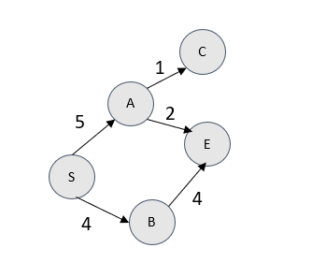

- The “Road Transport and Highways Division” of Bangladesh is working on a project where they want to establish six-lane highways among the 8 divisions of Bangladesh. Currently, there are 8 highways connecting these 8 divisions as given in the map below. Create a graph representation for the given map so that it does not take more than O(|V| + |E|) space/memory. (10 marks)
